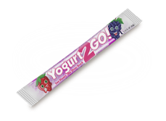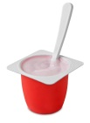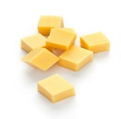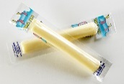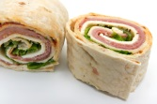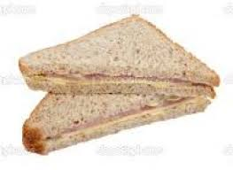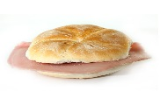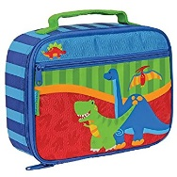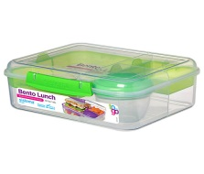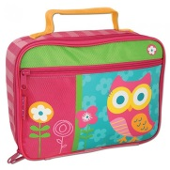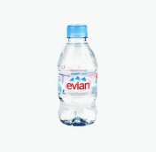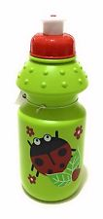

**What should I put into my child’s packed lunch?**

**Or why not try an alternative, soup, pasta, beans warmed up at home and put into an insulated flask to keep it warm till lunch time.**

**Please note we CAN NOT WARM FOOD THOUGH AT NURSERY.**

**A little bit of something else**

**Cheese**

**Sandwich or a wrap/pitta**

**Healthy Lunches**

**Please provide your child’s lunch in a box or in a bag, clearly labelled with their name.**

**Vegetable sticks or small pieces of fruit.**

**Drink**

**If you have any concerns or worries about lunches, please speak to**

**Claire or Kathryn (our Oral Health Champions)**

**Or your child’s keyworker**

**Things to keep in mind**

**VARIETY IS KEY** – something different each day/week

**FUN**– make it enjoyable, cut sandwiches into shapes using shaped cutters.

Try to get your child involved so they know what to expect in their lunch.

**DON’T overfill your child’s lunch box, children need much smaller portions than adults.**

**REMEMBER your child has access to milk 0r water throughout their session too.**